Hi,

For something awesome project I used Cygwin64 (https://www.cygwin.com/) to use Linux on windows, so I started with bandit on the website overthewire.org, I started with level 0 which was easy I just have to connect to ssh using the given username and password which was bandit0, for level 1 I just had to use the cat command of Linux to read the file readme and I got the password for level 1.

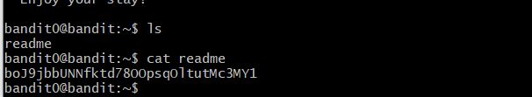

For Level 2 I just had to do cat from a special character by using cat ./- and I got the password for it.

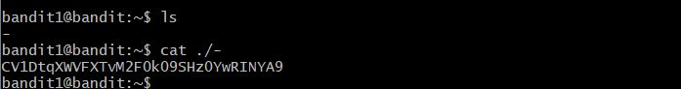

For Level 3 I had to read from file name which contain spaces in it so I just had to put "\" for every time it had a space.

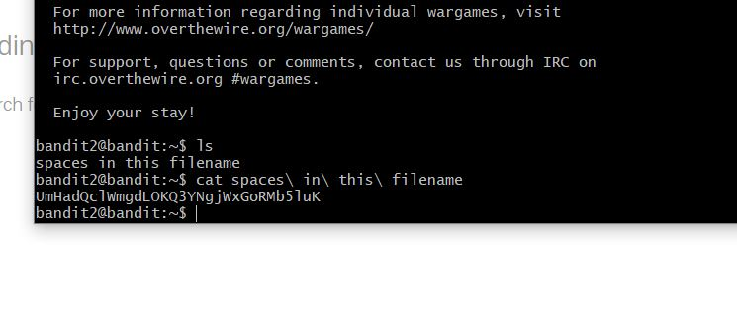

So for the Level 4 I had to switch directory using cd and the file was hidden so I just pressed "TAB" after cat and I got the file and read the password inside it.

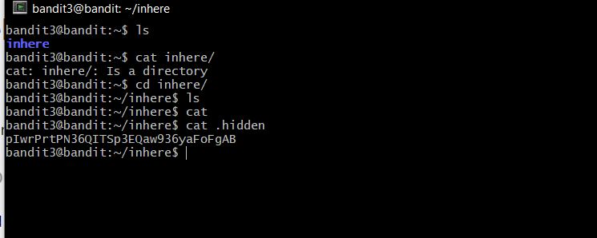

So for Level 5 it was really similar to level 2 just had to use ./ to read the file.

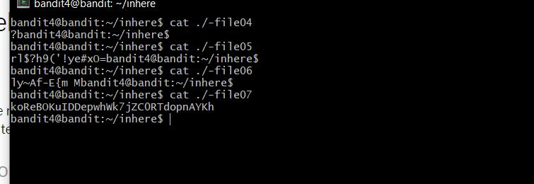

For the Next level I had use the command find to search through the current directory to look for the file of size 1033 btyes so by running the command "find ./ (./ for the current directory) -size 1033c" I found the location of that file and read the password for the next level.

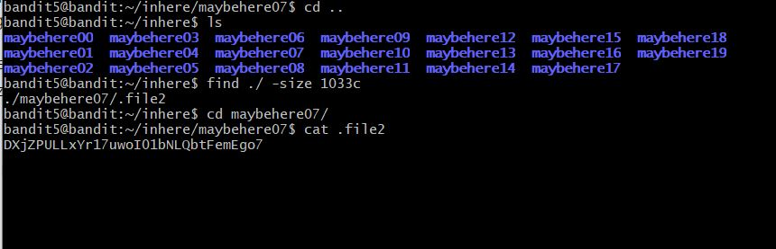

For Level 7 I used the same command from the pervious level "find" but this time I had to state the -user section and -group section which was owned by bandit 7 and bandit 6 respectivitly and I got bunch of permission denied but I got one directory which had the password for bandit7.

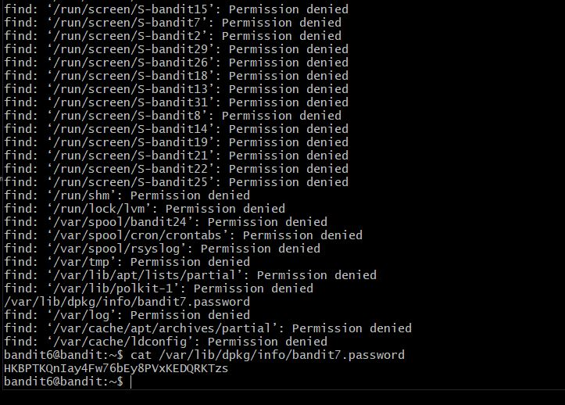

For Level 8 I was given a file called data.txt which had hell lots of strings in it and the hint said the password is next to the word "millionth", so for this I use a command called grep which work as a regular expression and search for a word in a particular file by running the command cat data.txt with "grep -i millionth" gave me the line which had password.

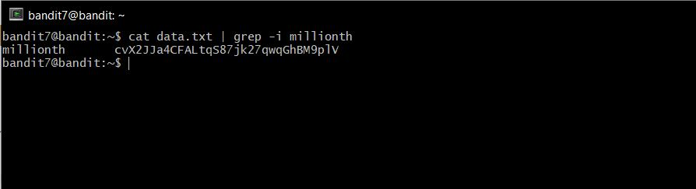

For this level, the file data.txt contain lots of multiple multiple string and the password only occur once so first I used sort command to sort the string in the data.txt and then run with uniq -u which only gives the unique string from a file and that's how I got the password.

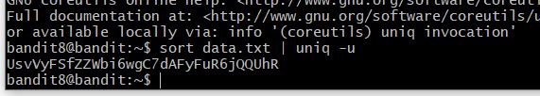

For Level 10 the file data.txt contain lots of non printable character in the file so I used the command strings <filename> which dumped all the printable character from the file and by scrolling through the output I found the password.

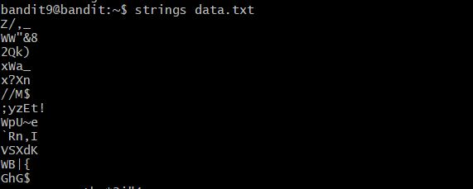

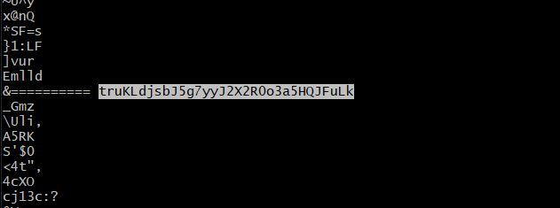

For Level 11 it had given a file data.txt which was been encrypted with base64 has the question clearly tells that so for this part I had to use the command "base64 -d data.txt" to get the decryption.

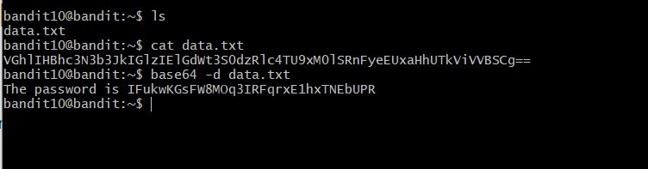

For the next Level the file data.txt had been encrypt using a method called rot13 so this was not too difficult as I just copied the encode value and used a online rot13 decryptor to get the password.

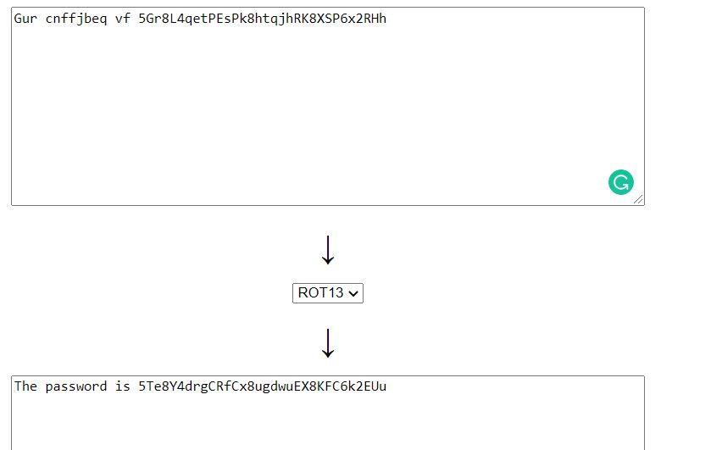

For the next Level, the file data.txt was compressed multiple times this took me a long time to do, first I used the command "xxd -r" to reverse the hexdump, and then after reversing the hex dump using the file command I check the file type of newfile which was Gzip compressed data so I had to decompress the file using the command "zcat -d <filename> >  newfile" and then checking the file type again this time is showed a bzip2 compressed data so I had to use the command "bzip2 -d  filename" to decompress it, as I read the file was compressed multiple times I had to keep on check the file type and after a while I got the file type as ASCII text and got the password.

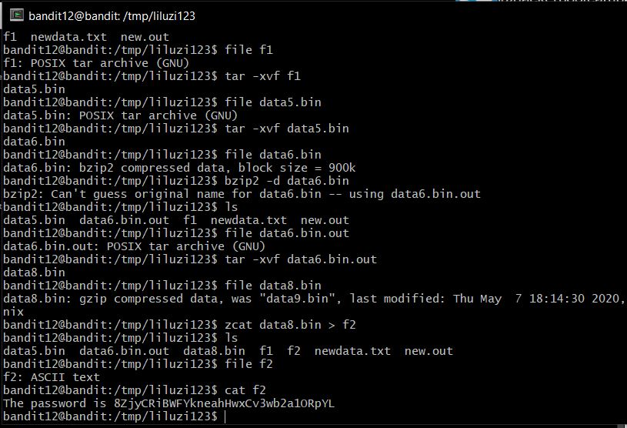

For Level 14, I was given a ssh private key for bandit 14 for this I used the commend "ssh -i sshkey.private [**bandit14@localhost**](mailto:bandit14@localhost)" to access the bandit14 using the private key and once I was in bandit14 I knew password was store in a particular directory so I read the pass from that dir.

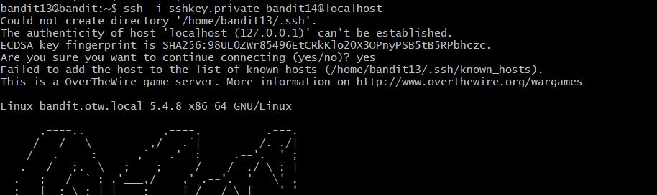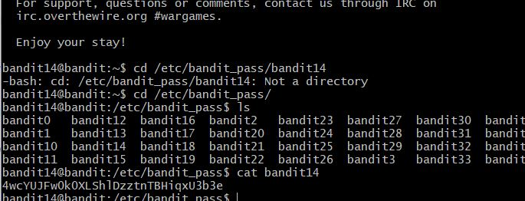

For Level 15, It said that I need to connect to the port 30000 in localhost and use the password of bandit 14 to get the next password, so I used the commend nc for this to make a connection with the localhost on port 30000 and after sending the password of bandit 14 I got the pass for next level 15.

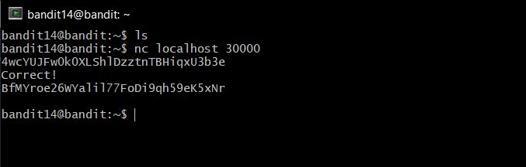

For Level 16, I had to submit  the current password to the port 31000 on localhost using SSL encryption, for this I had to use the command "openssl s_client -connect localhost:31000 -ign" to connect to the localhost on port 31000 using SSL encryption and then after submitting my current password I got the pass for Level 16.

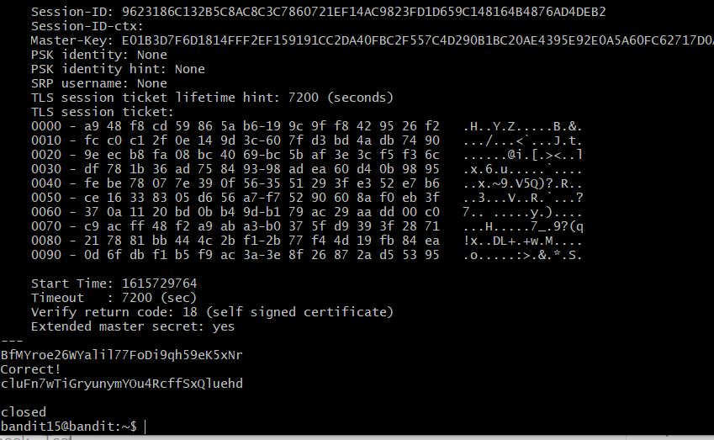

For the Level 17, this level took a lot of time for me, I was given a range of port from 31000 to 32000 and I had to find a open port which also had SSL in it. so for this level I used nmap to scan the port  the command I used is "nmap -sV localhost -p 31000-32000" which gave me some info about the open ports and one of the port had ssl/unknow and the other one was ssl/echo which was just gonna reply me with the same message I send so I made a connection with that port using the command "openssl s_client -connect localhost:port" and once the connection was made I enter the current password and I saw a private key instead of a password but from the pervious level I knew I had to use this key to get the access of bandit 17 and I saved the key in a file and used the command "ssh -i <key> [**bandit17@localhost"**](mailto:bandit17@localhost%22) and I got the access of bandit 17 and I followed the pervious method of get the password for level 17.

